**Skoovy (Android App)**

**Which Solves the Most Complex Problem Ever**

Hot Salsa Interactive or Rick Brown

Cole, Tyler; Kowal, Anthony; Matthews, Lily; Wever, Rudi;

**Second Demo or Prototype | Screenshots**

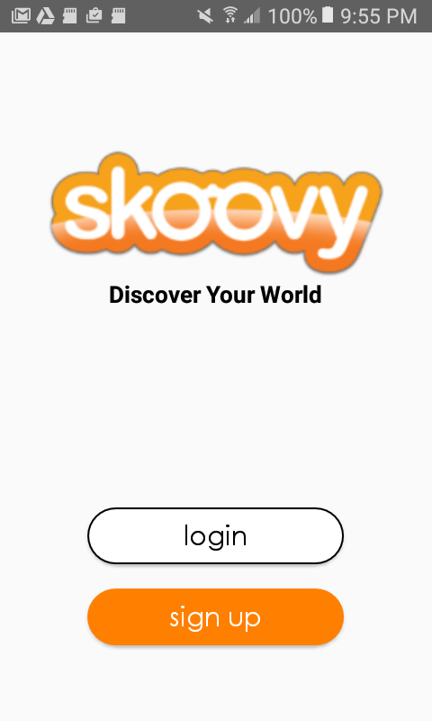

Figure 1. This is the start screen for the Skoovy App. Users can elect to create a new account via ‘sign up’ or existing users can ‘login’.

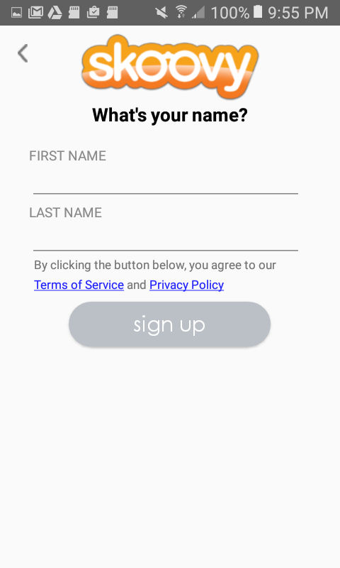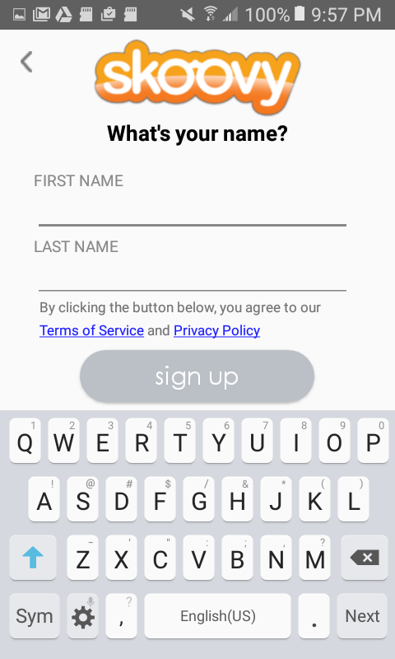

Figure 2. This is the Registration UI. User can input FIRST NAME and LAST NAME.

Figure 3. Once a user taps either input field, the soft keyboard is presented.

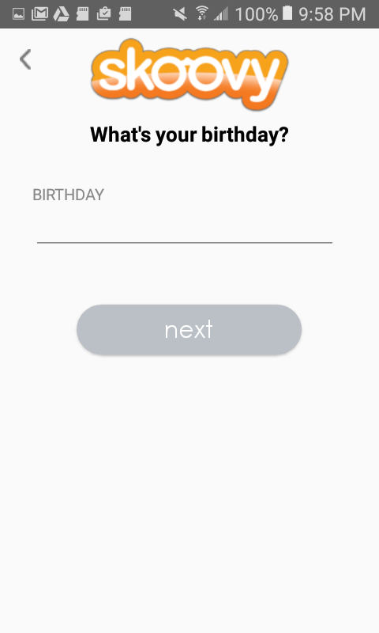

Figure 4. This is the Registration UI. User can input BIRTHDAY.

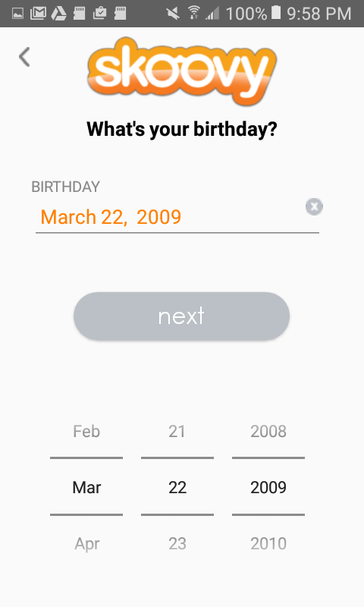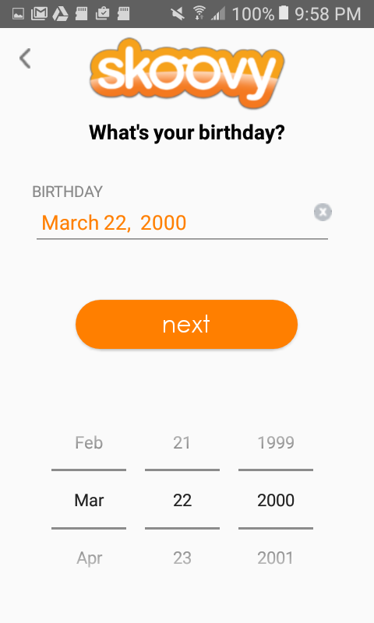

Figure 6. ‘next’ button changes color to denote a valid age greater than 13 years old. Now user is allowed to continue registration process.

Figure 5. Once user taps on input field, date spinner is presented for the user to select birthdate. (‘next’ button changes color to denote a valid age greater than 13 years old)

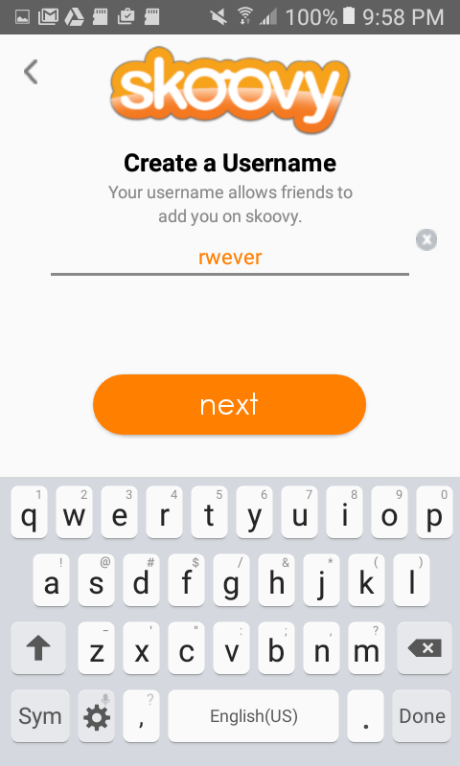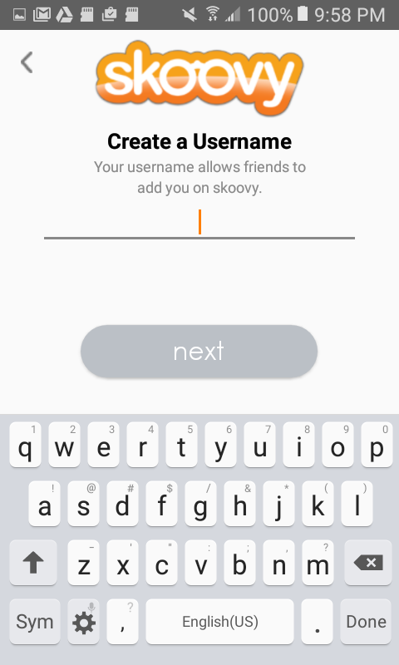

Figure 7. This is the Registration UI. User can input Username. The username is checked against existing usernames in database to ensure unique usernames are created.

Figure 8. ‘next’ button changes color to show that user is allowed to continue registration process.

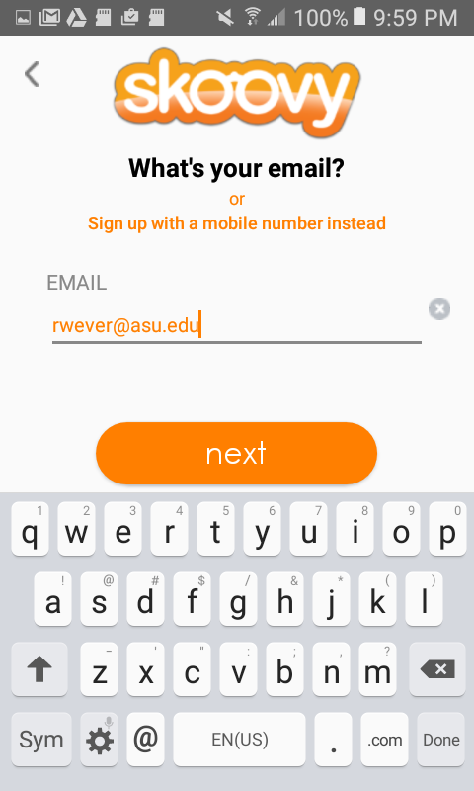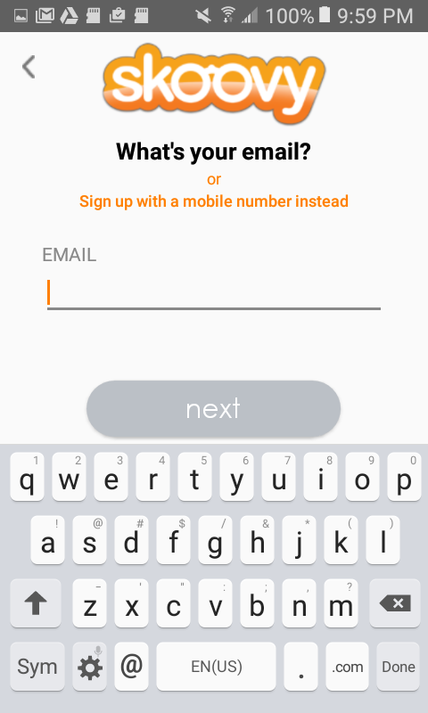

Figure 10. This is the Registration UI. User can input email (or select to continue registration with mobile number). The input is validated here to be proper syntax and the ‘next’ button changes colors to indicate that user is allowed to continue registration process.

Figure 9. This is the Registration UI. User can input email (or select to continue registration with mobile number).

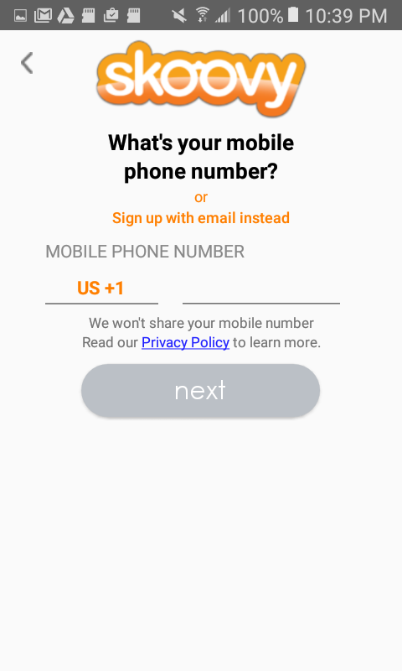

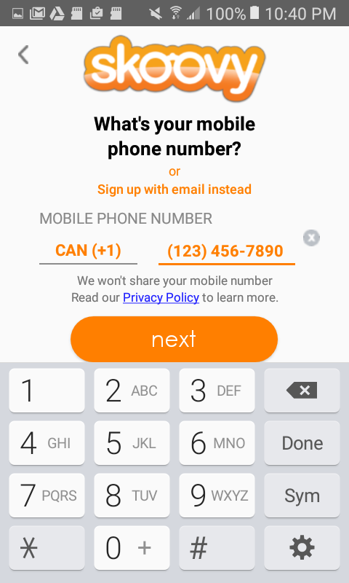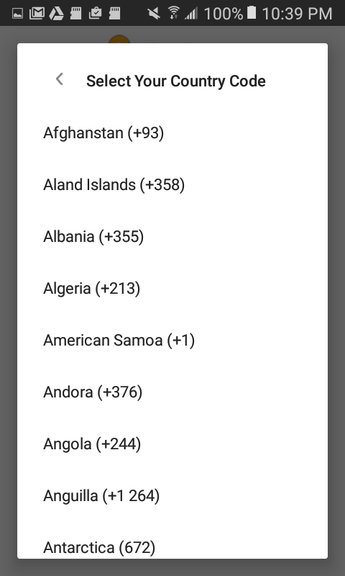

Figure 13. This is the Registration UI. User can input a phone number. Syntax is auto-formatted and validated to be proper length. ‘next’ button changes colors to indicate user is allowed to continue registration process.

Figure 11. This is the Registration UI. User can input mobile number (or select to continue registration with email). The input is validated here to be proper syntax and the ‘next’ button changes colors to indicate that user is allowed to continue registration process. *Default country code is US +1

Figure 12. This is the Registration UI. User can input a different country code prefix for the phone number.

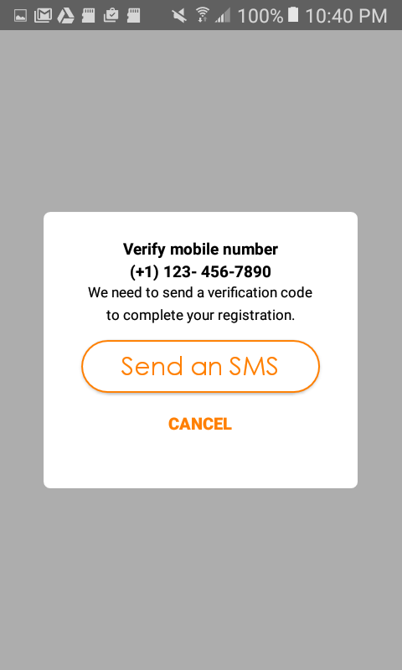

Figure 14. This is the Registration UI. User has inputted phone number. At this point the user needs to be verified, and may elect to do so via SMS.

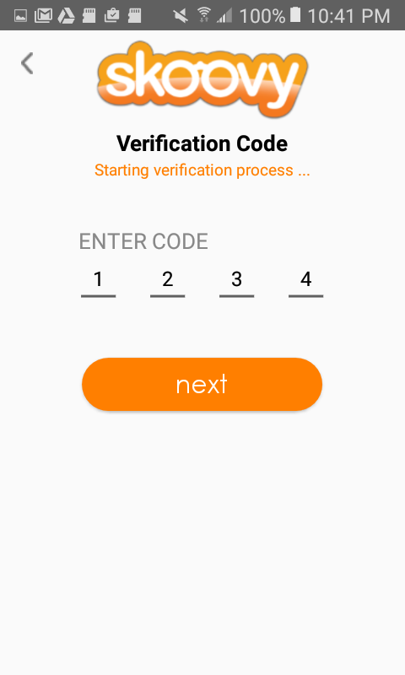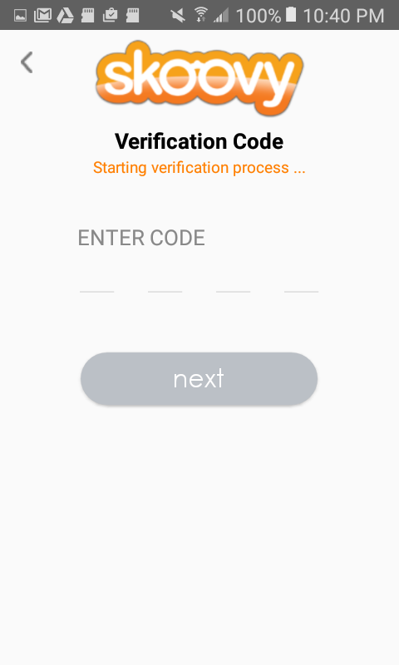

Figure 16. This is the Registration UI. User has inputted a 4-digit PIN and ‘next’ button changes color to indicate that user may continue with registration process.

Figure 15. This is the Registration UI. User has been sent a 4-digit PIN to supplied phone number. At this point the user inputs 4-digit PIN.

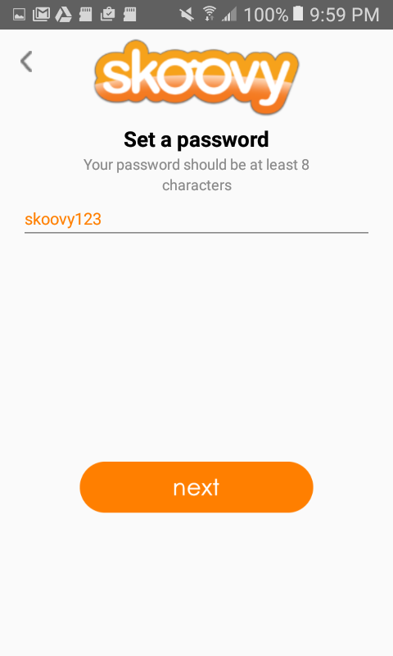

Figure 17. This is the Registration UI. User can input password. The input is validated here to be at least 8 characters in length and the ‘next’ button changes colors to indicate that user is allowed to continue registration process. At this point the user has been confirmed, the user registration is complete, and user profile is created.

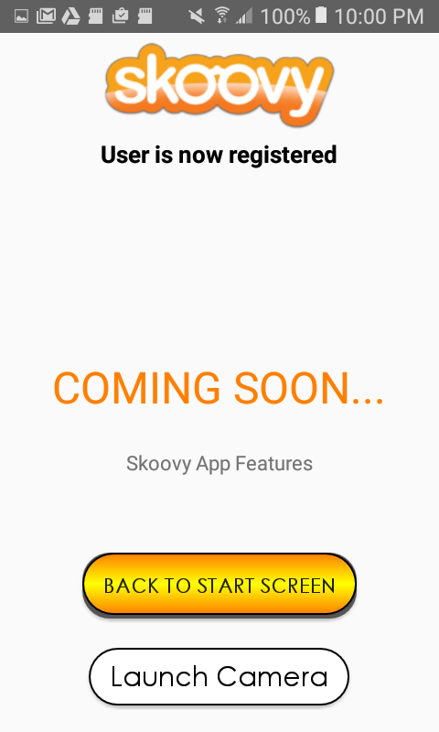

Figure 18. This is a temporary place holder screen. Normally a user-profile screen would be shown here. (Since that functionality has been omitted by our client, this allows the app to launch the camera activity.)

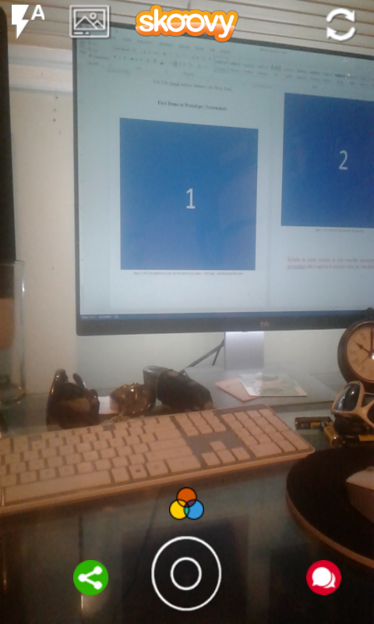

Figure 19. This is the Skoovy Camera Activity. Common usage is for the user create content by capturing an image or by recording video. Both image and video capture are done with single round center button. (Tap to take picture / Hold to take video) . *Image capture shown here. Flash toggle in upper left corner is user selectable and operates in either: automatic, on, or off modes.

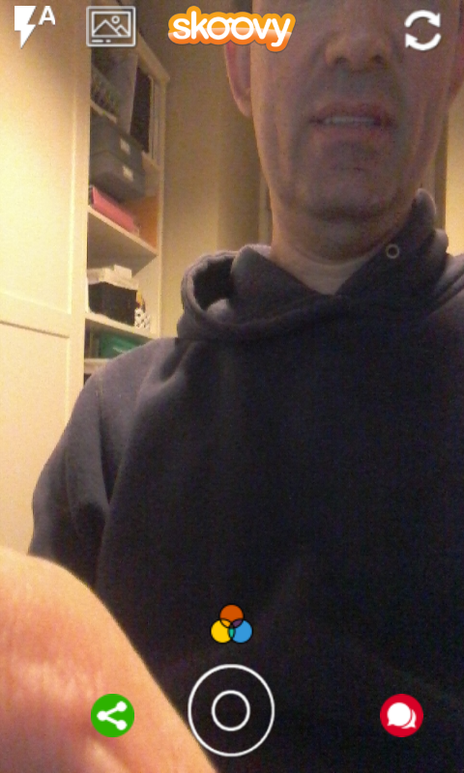

Figure 20. This is the Skoovy Camera Activity. By tapping the Dual-Arrow circle icon in the upper right corner, the front and rear facing cameras are toggled . *Front facing camera shown here.

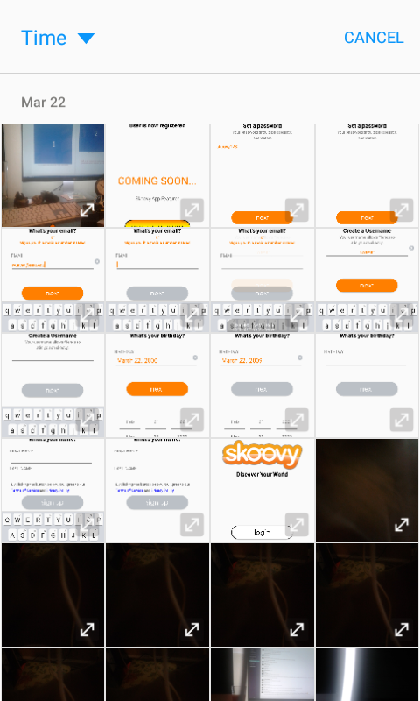

Figure 21. This is the Skoovy Camera Activity. Shown here is the the camera roll which the user can select from the main camera preview screen..



0:05.3

Figure 22. This is the Skoovy Camera Activity. By holding the center circular button the user can record a video. Custom chronometer shows recording elapsed time.

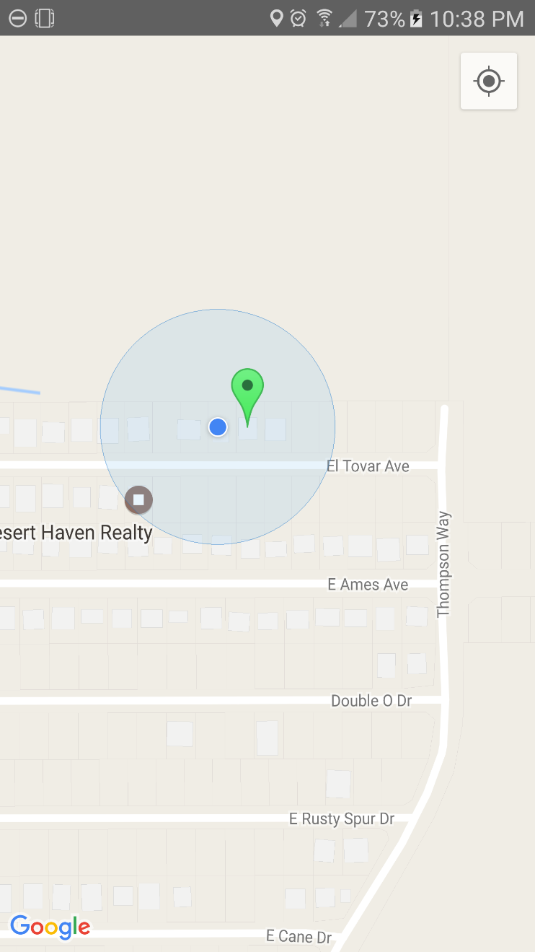

Figure 23. Upon entering the MapsActivity, the map is centered on the User's GPS Location.

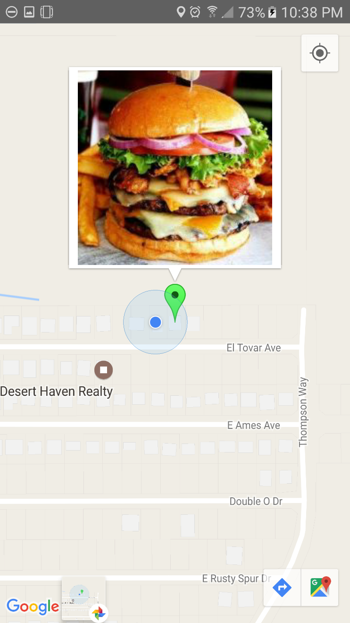

Figure 24. Tapping the marker will present the user with the geolocated content.

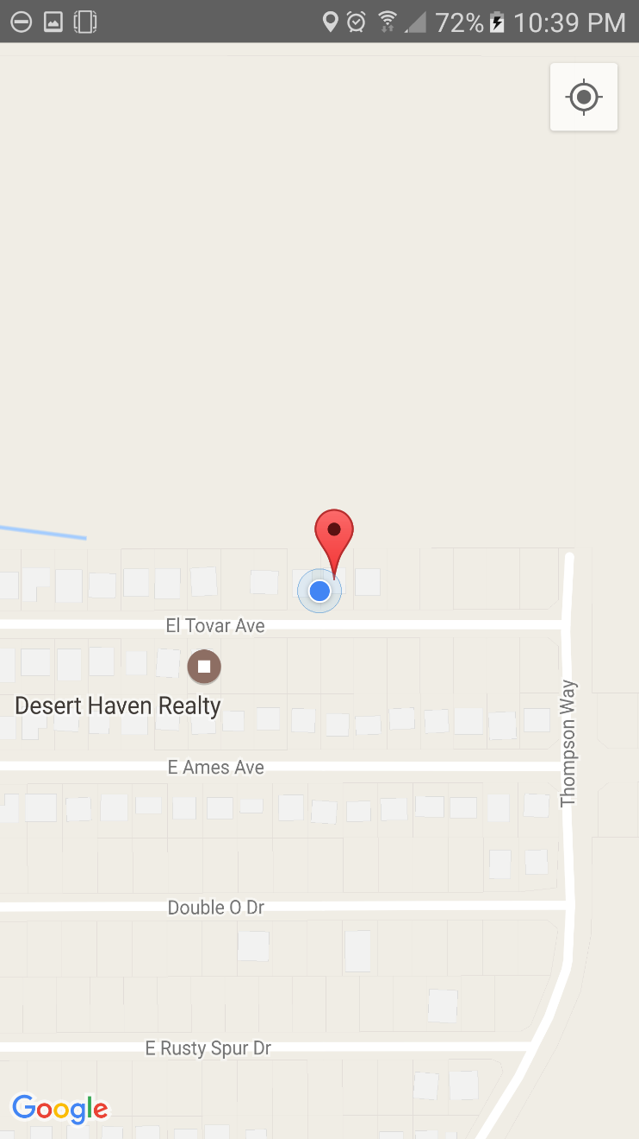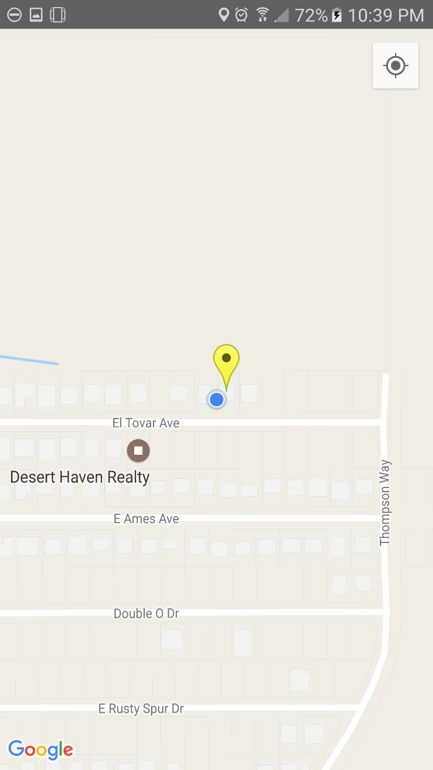

Figure 25. Different colored markers anotate different content. Green = Food, Yellow = Places, Red = Events

Figure 26. Different colored markers anotate different content. Green = Food, Yellow = Places, Red = Events